The most compact Motion Control System on the market
FAULHABER is introducing a new Motion Control System. More precisely: The world's smallest Integrated Motion Controller.
Integrated in the powerful brushless motors of the FAULHABER 22xx...BX4 family, the new Integrated Motion Controller 22xx…BX4 IMC, impresses users with its extensive range of functions and outstanding performance. Extension in length compared to the motor alone is 18mm only including a full featured servo controller and a 12 bit encoder. To top this, the full performance of the motors can be used in all different executions.
The version with RS232 interface is ideal for integration both from a PC or via an embedded master. The CANopen version is the perfect match for industrial automation networks. Being fully compliant with the CiA 402 servo drive standard allows direct support from typical PLCs. But even using the RS232 version several drives can be controlled using a single port of the master. Typical tasks like homing a drive can directly be executed by the integrated Motion Controller using its local digital and analog I/Os.
Alternatively, both versions can also be operated without a master in "stand-alone" mode. Its digital and analog I/Os can then be used very flexible for local control tasks or for discrete set-point and actual values.
Of course the compact 22xx…BX4 IMC can be combined with many products from the FAULHABER product range such as the compact GPT gearheads and the new FAULHABER 22L linear actuators.
Efficient and highly dynamic
The built-in current control automatically provides protection against overloading and there is also a diagnostic function. Supported are torque, velocity or position control according to the servo-drive standard. These features are complemented by low EMC emissions and the obligatory CE label.
The brushless motors with the new Integrated Motion Controller 22xx…BX4 IMC are available in two lengths, having first-class volume-to-performance ratio as well as highly dynamic control characteristics. They are suitable for a wide range of market segments such as medical and laboratory technology, automation technology, robotics or special industrial machinery.
Compact complete solution in proven quality
The diameter-conform design provides users with a system solution that minimizes space and resources as well as wiring requirements. Simply connect to the application and get started. Furthermore, the free Motion Manager 7.1 software from FAULHABER likely is the best in class tool for easy configuration and system integration. The user interface enables easy system setup and provides access to the extended diagnostic functions. To allow for a quick start, programming adapters for RS232, CANopen and USB are available as accessories.

293 words / 2,357 characters
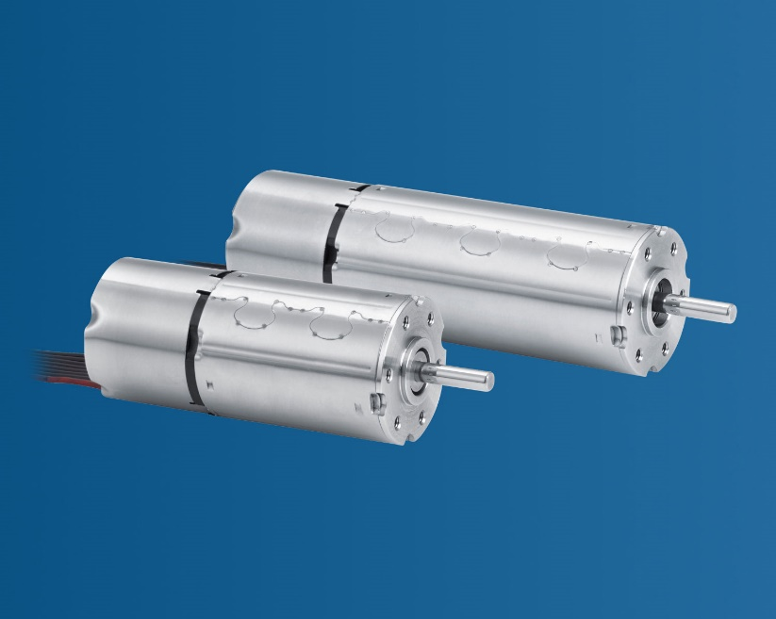 | [picture]  The most compact Motion Control System on the market© FAULHABER

Press contact (Germany + International)  Dr. Fritz Faulhaber GmbH & Co. KG  Kristina Wolff – Marketing  Faulhaberstraße 1 · 71101 Schönaich  Germany  T +49 7031 638-148 · F +49 7031 638-8148  redaktion@faulhaber.com | Press contact (Switzerland)  FAULHABER SA  Ann-Kristin Hage-Ripamonti – Marketing  6980 Croglio  Switzerland  T +41 91 61 13 239 · F +41 91 611 31 10  marketing@faulhaber.ch

