Schönaich, July 8, 2022
75 years of FAULHABER

The success story of FAULHABER starts at the end of the 1940s when a young engineer by the name of Dr. Fritz Faulhaber founds “Feinmechanischen Werkstätten” in Schönaich, Germany. During his previous development work on the revolutionary camera model “Vitessa” for the renowned company Voigtländer, he already had the idea of using an electric motor to transport film.

As he can’t find a motor small enough and with the necessary efficiency and performance when battery-operated, Dr. Fritz Faulhaber works on his own solution in the mid-1950s and, with the ironless, self-supporting, skew-wound design, invents an innovative drive technology that would solve not only his camera problem, but also form the basis for the future of miniaturization in many application areas worldwide.

Since then, FAULHABER has been at the forefront of the global trend for continuous miniaturization with innovative micro drive solutions. The founder’s spirit, which was both creative and pragmatic, shapes the company to this day. At FAULHABER, we think long-term, monitor the market carefully and take a proactive approach – or as Dr. Fritz Faulhaber Junior, son of the founder, once modestly said: “It is our philosophy to always be technologically ahead by a nose length – but the nose shouldn't be a meter long.”
As a traditional family-run company, FAULHABER highly values being able to make independent business decisions without having to answer to third-party interests. An important aspect is the investment in fundamental research, thereby enabling us – in keeping with our founder's philosophy – to have new drive technologies up our sleeves ready for the trends of tomorrow, long before the customers start asking for them. This ability to identify new application areas for innovative drive systems at an early stage is one of the reasons for the continued success.
Over the past 75 years, the FAULHABER family of companies has gained many new members around the world. These are extremely well networked with each other – not only for product development, but above all for synchronized production across locations. So it’s only fitting that the 75th anniversary coincides with the 60-year presence of FAULHABER in Switzerland – namely the family member Minimotor S.A. FAULHABER is proud to celebrate this anniversary together.

We are technological leaders in the field of miniature and micro drive technology thanks to FAULHABER’s reputation for working on the solutions of tomorrow and of the future well beyond that. In this way, over the last 75 years, the company has repeatedly succeeded in using innovative products to develop new system solutions for a wide range of customers in a variety of different markets. The customers trust in FAULHABER’s ability to reliably find specific solutions for complex new problems. This ability is based on our willingness to form close partnerships, and on the innovative power of diversity that FAULHABER draws from its international cooperative network.

What FAULHABER has learned from the exciting past 75 years is how important corporate courage and foresight were and are – not only for FAULHABER, but also for the many customers whose applications would not have been possible without this forward-thinking. This is why the company has established the following claim for the future:“For every technological innovation that can help to improve people's lives, FAULHABER should always have the appropriate drive solution.”

www.faulhaber.com/en/motion/75-years-of-motion/
75 Years - FAULHABER Drive Systems
[537 words / 3,463 characters]

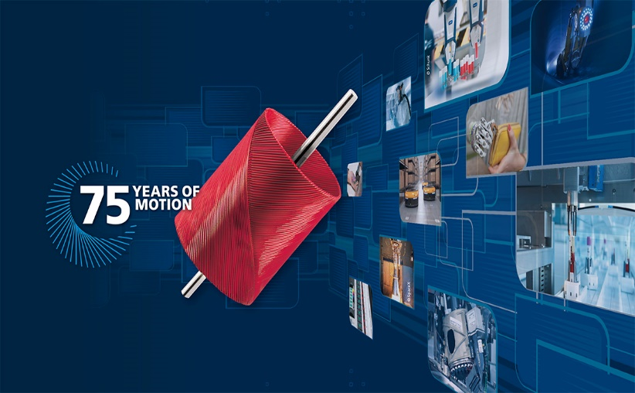 | 75 years of FAULHABER  © FAULHABER

[Bi | 60 years of Minimotor  © FAULHABER

Press contact (Germany + International)  Dr. Fritz Faulhaber GmbH & Co. KG  Kristina Wolff – Marketing  Daimlerstraße 23/25 · 71101 Schönaich  Germany  T +49 7031 638-148 · F +49 7031 638-8148  redaktion@faulhaber.com | Press contact (Switzerland)  FAULHABER MINIMOTOR SA  Ann-Kristin Hage-Ripamonti – Marketing  6980 Croglio  Switzerland  T +41 91 61 13 239 · F +41 91 611 31 10  marketing@faulhaber.ch

